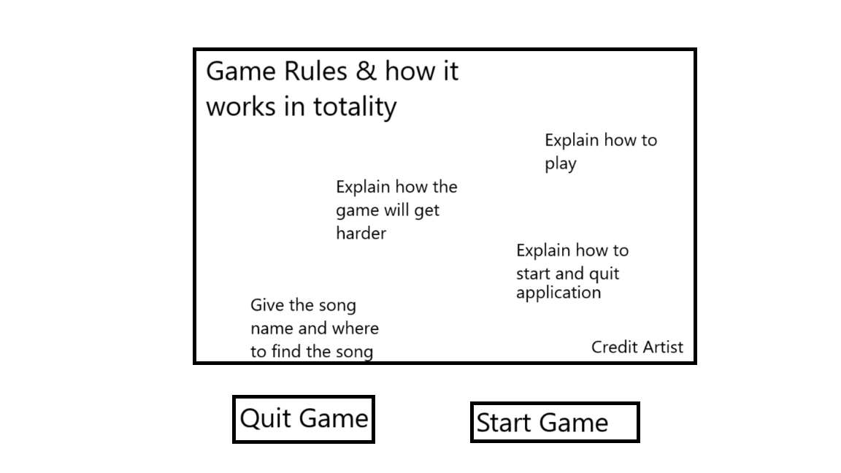
Main Title
This is the main title screen of the game, and it’s a simpler one for the simplicity of the game. This game is going to be a rhythm game for a song that my brother made (kite with no wind). The main title screen will have the game explanation as well as how to play, how to win, as long as credit to the song artist.
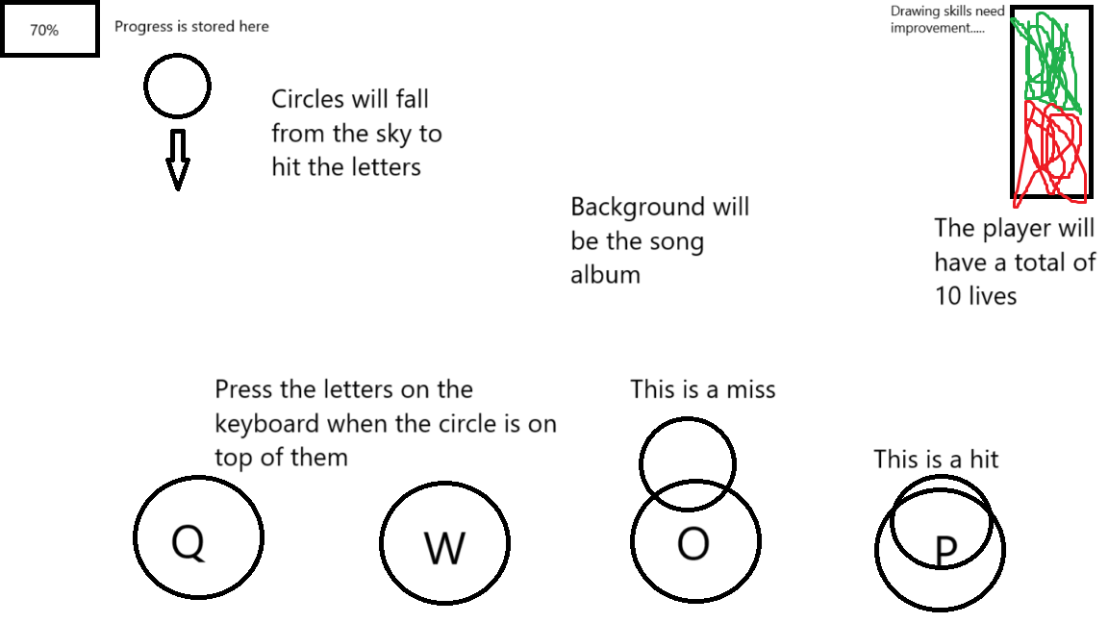
Main Game Screen
This is the main game screen. The game will have 4 keys you need to press (Q, W, O, and P) Pressing these keys will make them light up a different color. There will be circles that also fall from the top of the screen in specific spots. Hitting the key correlated to where the circle spawns in will keep you alive. If you miss a circle, you will take 1 point of damage. If you take 10 hits, you will have to restart. You will be able to track your progress with the progress bar in the top left, as well as your health in the top right. If you make it to the end of the song, you will have beat the game and will be sent back to the home screen to try again if you feel the urge to do so.
Sprites
The sprites that will be needed for the game will be 4 different colored buttons for the keys you need to press, as well as 3 different circles to represent their state (Falling, Hit, and Missed) These 3 states will help keep the player in check with how well they are doing. There will also need to be the album cover for the background. This will be used to help create the atmosphere of the game. The game will also use elements built into pygame, such as the standard blocks and text to create the home screen and UI elements.
Sound Effects
This game will use some extra sounds to make you feel like you’re adding to the music, as most rhythm games add a snare or kick to the key presses. The keys will all use a quiet snare sound effect to help mimic the idea that you’re adding some of your own additions to the song. We will also be using the song, as it would be hard to make a rhythm game without a song to play to.
Sprite List
The sprite list for the game will all be listed below. The sprites will all be found free of use besides the background which will be the cover art image for the song. The keys I found for the game are these…
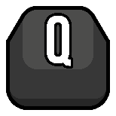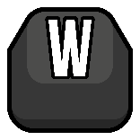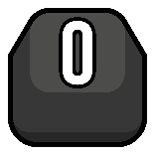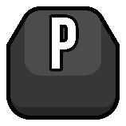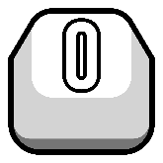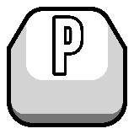

These keys will be white when not pressed and when pressed will turn into the darker counterpart. This will help the player determine if the key has been pressed or hasn’t been pressed. The Background will be the image listed below.
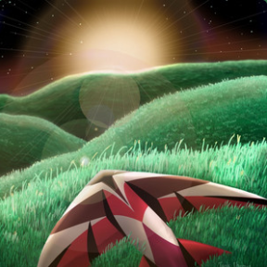
This image is the image that is used for the cover art for the song on Spotify and was designed by Simeon Wiseman. I will be getting a bigger and better resolution image for the game to make the resolution look more consistent.
Make a time stamp editor
For this game editor I will need to implement a time stamp keeper,
2 – Make a different playback timer (Time the notes falling)
3 – determine how close the note is to the key area
4 -

